Complex Engineering Problem for Power Electronics (EE-313)
Project Title:
Design and Implementation of a Microcontroller-Based Speed Control System for a DC Motor Using a Three-Phase AC Supply.
Abstract:
This project focuses on the design, simulation, and implementation of a DC motor speed control system powered by three-phase AC to DC conversion. The study begins with a comprehensive literature review of conventional speed control methods for DC shunt and series motors, including flux control, armature resistance control, and voltage control techniques. Modern approaches such as Pulse Width Modulation (PWM) and Proportional-Integral-Derivative (PID) control are also explored for achieving precise and stable regulation under varying load conditions. A three-phase rectifier system both uncontrolled and controlled, is designed and simulated in MATLAB and Multisim to ensure efficient and reliable power conversion. The hardware implementation incorporates sensors such as optical encoders and Hall-effect modules, interfaced with a microcontroller (Arduino/STM32), to measure and regulate motor speed. The complete system is integrated into a functional prototype, enabling both simulation-based validation and experimental testing. The outcomes of this project highlight the trade-offs between different control methods in terms of efficiency, accuracy, and practicality, while demonstrating a cost-effective, scalable solution for industrial applications requiring variable DC motor speed control.
Task Identification
Literature Review
- Speed Control of a DC Motor:
Speed control of a DC motor can be manual or automated. Unlike speed regulation, which aims to maintain consistent speed despite load changes, speed control adjusts the motor’s speed as needed.
The speed of a DC motor (N) is equal to:
$$N=\frac{V-I_{a}R_{a}}{k∅}$$
Therefore speed of the 3 types of DC motors; shunt, series and compound, can be controlled by changing the quantities on the right-hand side of the equation above.
Hence the speed can be varied by changing:
  - The terminal voltage of the armature, V.
  - The external resistance in armature circuit, R_{a}.
  - The flux per pole, φ.
Terminal voltage and external resistance involve a change that affects the armature circuit, while flux involves a change in the magnetic field. Therefore speed control of DC motor can be classified into:
  - Armature Control Methods
  - Field Control Methods
We will discuss how both of these methods control the speed of DC series motors and DC shunt motors.
  - Speed Control of D.C. Shunt Motor:
The speed of a shunt motor can be changed by:
- flux control method.
- armature control method.
- voltage control method.
The first method (i.e. flux control method) is frequently used because it is simple and inexpensive.
- Flux control method:
The flux control method of speed regulation in DC motors is based on the fundamental relation:
$$N∝\frac{1}{∅}$$
where 𝑁 is the motor speed and 𝜙 is the field flux. By decreasing the field flux, the motor speed can be increased. Practically, this is achieved by inserting a variable resistance (commonly referred to as the shunt field rheostat) in series with the shunt field winding (Fig. 1.1).
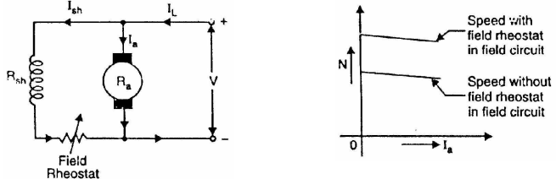
Fig 1.2
Fig 1.1

When the rheostat resistance is increased, the shunt field current $I_{sh}$​ reduces, resulting in a weaker field flux. Consequently, the motor speed rises above its rated value (Fig. 1.2). This method is particularly effective for applications requiring speeds higher than the base speed.
However, the flux control method has inherent limitations. The speed range achievable is generally restricted to a ratio of about 3:1. Beyond this limit, further reduction in flux may cause problems such as instability, poor commutation, and excessive sparking at the brushes. Additionally, the torque produced is inversely proportional to the speed, which reduces the motor’s capability to handle heavy mechanical loads at higher speeds.
Advantages:
    - This is an easy and convenient method.
    - It is an inexpensive method since very little power is wasted in the shunt field rheostat due to relatively small value of I_{sh}.
    - The speed control exercised by this method is independent of load on the machine.
Disadvantages:
    - Only speeds higher than the normal speed can be obtained since the total field circuit resistance cannot be reduced below R_{sh}, the shunt field winding resistance.
    - There is a limit to the maximum speed obtainable by this method. It is because if the flux is too much weakened, commutation becomes poorer.

  - Armature control method:
The armature control method is one of the simplest techniques used for controlling the speed of a DC motor. The principle is based on the relationship between the motor speed N and the back electromotive force (EMF) E_{b}​, where:
$$N∝E_{b}$$
and
$$​E_{b}=V-I_{a}​(R_{a}​+R_{c})$$
Here, V is the supply voltage, I_{a} is the armature current, R_{a}​ is the armature resistance, and R_{c} is the external controller resistance.
In this method, a variable resistance (known as controller resistance) is introduced in series with the armature winding (Fig. 1.3). By adjusting this resistance, the effective voltage across the armature is reduced, thereby lowering the back EMF. Since speed is directly proportional to back EMF, the motor speed decreases accordingly (Fig. 1.4).
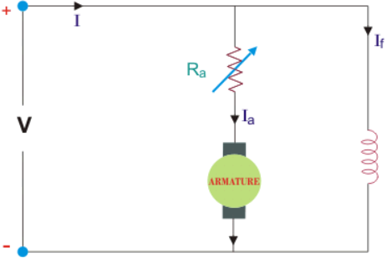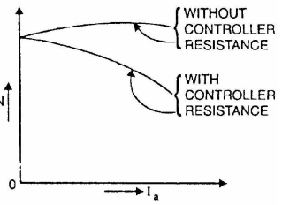
Fig 1.3 Fig 1.4
The maximum speed obtainable in this method is the rated or normal speed, which corresponds to the condition when R_{c}=0. Thus, the armature control method can only be used to achieve speeds below the rated value.
Although the technique is straightforward and inexpensive, it has several disadvantages. The major limitation is low efficiency, since a significant amount of power is wasted as heat in the external resistance. Additionally, speed regulation is poor under varying load conditions, and the method is not suitable for continuous operation in modern industrial applications. Despite these drawbacks, armature control is still used in certain low-cost and low-power systems where efficiency is not a primary concern.
Advantages:
- The method is straightforward, requiring only a series resistance connected with the armature. This makes the circuit design and operation easy to understand and implement.
Disadvantages:
- A large amount of power is wasted in the controller resistance since it carries full armature current Ia.
- The speed varies widely with load since the speed depends upon the voltage drop in the controller resistance and hence on the armature current demanded by the load.
- The output and efficiency of the motor are reduced.
- This method results in poor speed regulation.

  - Voltage control method:
In the armature voltage control method, the voltage source supplying the field winding is kept separate from the source that supplies the armature. This arrangement eliminates the major disadvantages associated with the simple armature resistance control method, such as poor speed regulation and reduced efficiency. However, the system is comparatively expensive and is therefore mainly employed in large-size DC motors where efficiency and performance are critical.
There are two common approaches to armature voltage control:
- Multiple Voltage Control:
In this method, the shunt field of the motor is permanently connected across a constant-voltage source, while the armature can be connected to different voltage levels using suitable switchgear. By changing the applied voltage across the armature, the motor speed can be adjusted, since speed is approximately proportional to armature voltage. Intermediate speed ranges can be obtained through a shunt field regulator.
- Ward–Leonard System:
One of the most versatile and widely used methods of DC motor control is the Ward–Leonard system. In this setup, an adjustable-voltage DC generator is used to supply the armature of the motor whose speed is to be controlled. The generator is driven by a constant-speed AC motor, and both the motor field and generator field are excited by a separate DC source (exciter). By varying the generator field current through a regulator, the output voltage of the generator can be adjusted, thereby controlling the armature voltage of the motor.
Reversal of motor rotation is possible by reversing the generator field current using a controller (FC). In some cases, an additional field regulator is also included in the motor field circuit for fine speed adjustment. This method allows smooth control over a wide range of speeds, including reversal, making it highly flexible and efficient.
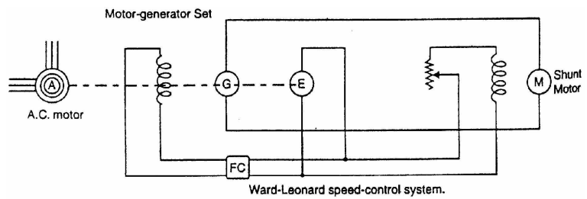
Fig 1.5
Advantages:
    - The speed of the motor can be adjusted through a wide range without resistance losses which results in high efficiency.
    - The motor can be brought to a standstill quickly, simply by rapidly reducing the voltage of generator G. When the generator voltage is reduced below the back EMF of the motor, this back EMF sends current through the generator armature, establishing dynamic braking. While this takes Fig. (1,5) place, the generator G operates as a motor driving motor A which returns power to the line.
    - This method is used for the speed control of large motors when a DC supply is not available.
Disadvantages:
    - Requires additional equipment such as generators, switchgear, and regulators.
    - The Ward–Leonard system in particular demands large space and maintenance.
    - More complicated compared to simple resistance or flux control methods.

  - Speed Control of D.C. Series Motor:
The speed control of DC series motors can be obtained by
- flux control method.
- armature-resistance control method.
- Flux control method:
In this method, the flux produced by the series motor is varied and hence the speed. The variation of flux can be achieved in the following ways:
- Field diverters:
In this method, a variable resistance (called field diverter) is connected in parallel with series field winding as shown in Fig. (1.6). Its effect is to shunt some portion of the line current from the series field winding, thus weakening the field and increasing the speed. The lowest speed obtainable is that corresponding to zero current in the diverter (i.e., diverter is open). Obviously, the lowest speed obtainable is the normal speed of the motor. Consequently, this method can only provide speeds above the normal speed. The series field diverter method is often employed in traction work.
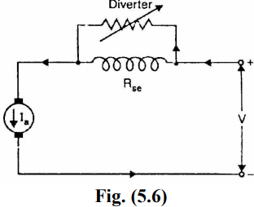
Fig 1.6
Advantages:
  - Simple and economical method.
  - Provides smooth speed control above normal speed.
  - Commonly used in traction systems where higher than normal speed is required.
Disadvantages:
- Cannot obtain speeds below normal.
- Extra resistance causes power loss.
- Speed regulation is poor (speed changes with load).

      - Armature diverter:
In order to obtain speeds below the normal speed, a variable resistance (called armature diverter) is connected in parallel with the armature as shown in Fig. (1.7). The diverter shunts some of the line current, thus reducing the armature current. Now for a given load, if I_{a} is decreased, the flux f must increase. Since, the motor speed is decreased. By adjusting the armature diverter, any speed lower than the normal speed can be obtained.

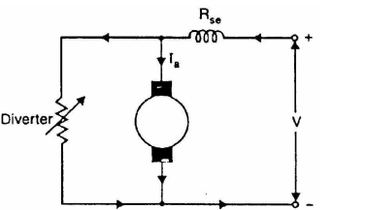
Fig 1.7

Advantages:
- Enables speed control below normal speed.
- Smooth and continuous control possible.
- Useful when motor is required to run slowly under heavy load conditions.
Disadvantages:
- Considerable power loss in diverter resistance.
- Efficiency becomes poor.
- Speed regulation is not good (speed depends on load).

- Tapped field control:
In this method, the flux is reduced (and hence speed is increased) by decreasing the number of turns of the series field winding as shown in Fig. (1.8). The switch S, can short circuit any part of the field winding, thus decreasing the flux and raising the speed. With full turns of the field winding, the motor runs at normal speed and as the field turns are cut out, speeds higher than normal speed are achieved
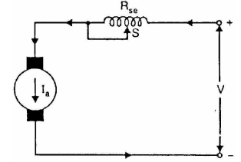
Fig 1.8

Advantages:
- More efficient compared to diverter methods (since no large external resistors used).
- Provides speeds above normal speed.
- Construction is simple and compact.
Disadvantages:
- Provides only stepwise (discrete) speed control, not smooth.
- Not flexible (limited to available tap connections).
- Speeds below normal cannot be obtained.

- Armature resistance control:
In this method, a variable resistance is directly connected in series with the supply to the complete motor as shown in Fig. (1.9). This reduces the voltage available across the armature and hence the speed falls. By changing the value of variable resistance, any speed below the normal speed can be obtained. This is the most common method employed to control the speed of dc. series motors. Although this method has poor speed regulation, this has no significance for series motors because they are used in varying speed applications. The loss of power in the series resistance for many applications of series motors is not too serious since in these applications, the control is utilized for a large portion of the time for reducing the speed under light-load conditions and is only used intermittently when the motor is carrying full-load.
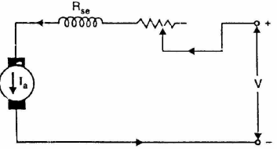
Fig 1.9

Advantages:
    - Very simple and cheap arrangement.
    - Provides a wide range of speeds below normal speed.
    - Commonly used in practice for traction, cranes, hoists, elevators etc.
Disadvantages:
- Very inefficient (large power loss in series resistance).
- Poor speed regulation (speed falls heavily with load).
- Resistor may overheat under heavy current.

- Methods of Conversion of Three Phase A.C to D.C:
Converting three phase AC to DC can be achieved by two different methods.
- Three phase uncontrolled rectifier.
- Three phase controlled rectifier.

  - Three Phase Uncontrolled Rectifier:
The full-wave three-phase uncontrolled bridge rectifier circuit uses six diodes, two per phase in a similar fashion to the single half-wave 3-phase rectifier as it has a frequency of six times the input AC waveform. Also, the full wave rectifier can be fed from a balanced 3–phase 3-wire delta connected supply as no fourth neutral (N) wire is required. Consider the full-wave 3-phase rectifier circuit below.
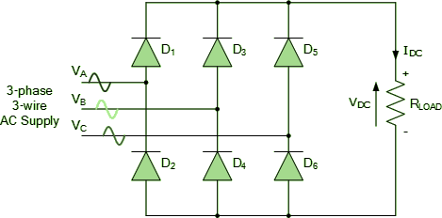
As before, assuming a phase rotation of Red-Yellow-Blue (VA – VB – VC) and the red phase (VA) starts at 0o. Each phase connects between a pair of diodes as shown. One diode of the conducting pair powers the positive (+) side of load, while the other diode powers the negative (-) side of load. Diodes D1 D3 D2 and D4 form a bridge rectifier network between phases A and B, similarly diodes D3 D5 D4 and D6 between phases B and C and D5 D1 D6 and D2 between phases C and A. Diodes D1 D3 and D5 feed the positive rail. The diode which has a more positive voltage at its anode terminal conducts. Likewise, diodes D2 D4 and D6 feed the negative rail and whichever diode has a more negative voltage at its cathode terminal conducts. Then we can see that for three-phase uncontrolled rectification the diodes conduct in matching pairs with each conduction path passing through two diodes in series. Thus a total of six rectifier diodes are required with commutation of the circuit taking place every 60o, or six times per cycle. If we start the pattern of conduction at 30o, this gives us a conduction pattern for the load current of: D1-4 D1-6 D3-6 D3-2 D5-2 D5-4 and return again to D1-4 and D1-6 for the next phase sequence as shown, Full-wave Three-phase Rectifier Conduction Waveform.
Fig 2.1
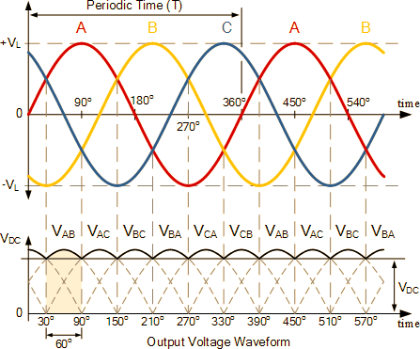
Fig 2.2
In a three-phase power rectifier, conduction always takes place through the most positive diode on the positive side and the most negative diode on the negative side. As the three-phase voltages rotate across the rectifier terminals, conduction is sequentially transferred from one diode pair to the next. Each individual diode conducts for 120° (one-third of the cycle), but since conduction occurs in pairs of diodes, each pair conducts for only 60° (one-sixth of the cycle) at a time.
Advantages:
    - Circuit design is straightforward, making the rectifier easy to implement.
    - Absence of control circuitry reduces overall cost.
    - Fewer components lead to fewer failure points, ensuring long operational life.
    - The 3-phase configuration produces smoother DC output.
Disadvantages:
- Output DC voltage is constant and cannot be adjusted, making it unsuitable for applications requiring variable DC.
- Higher harmonic content in the output increases stress on the supply system and degrades power quality.
- Harmonic currents and lack of control reduce the input power factor.
- Since it is uncontrolled, the rectifier cannot regulate output according to varying load conditions, leading to less efficient power utilization.

- Three Phase Controlled Rectifier:
This converter is widely used in industrial power applications up to about 120 kW, particularly where two-quadrant operation (rectification and inversion) is required. Due to its configuration, it is also known as a three-phase full-wave bridge converter or a six-pulse converter.
The six thyristors are triggered sequentially at an interval of:
$$\frac{π}{3}​radians(60∘)$$
The output ripple frequency is:
$$f_{r}=6f_{s}​$$
where f_{s}​ = supply frequency.
Since the ripple frequency is higher, the filtering requirement is less compared to three-phase half-wave or semi-converters.
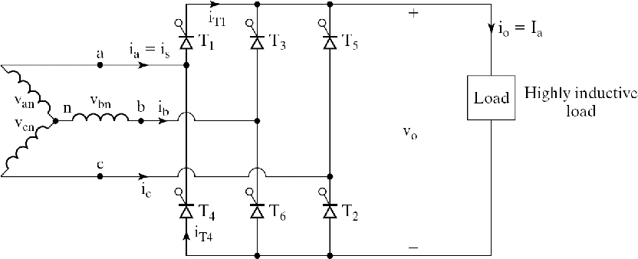
Fig 2.3

When the firing angle is considered, at:
$$ωt=(\frac{π}{6}​+α),$$
thyristor T₁ is triggered while T₆ is still conducting. As a result, thyristors T₁ and T₆ conduct together and the line-to-line voltage V_{ab}​ is applied across the load for the interval
$$(\frac{π}{6}​+α)≤ωt≤(\frac{π}{2}​+α).$$
At
$$ωt=(\frac{π}{2}​+α),$$
thyristor T₂ is fired, which forces T₆ to turn off naturally due to line commutation. From this instant up to
$$ωt=\left(\frac{π}{6}​+α\right).$$
thyristors T₁ and T₂ conduct, applying the line-to-line voltage V_{ac} cross the load.
The process continues in a cyclic manner, with each thyristor conducting for 120°, while conduction always occurs in pairs for 60° intervals. The overall firing sequence of the converter is:
T₁​​T₂​→T₂T₃​→T₃T₄​​→T₄​T₅ ​→T₅T₆​→T₆T₁​→…S

- Measurement of Speed of a DC Motor Using Microcontroller:
Measuring the speed of a DC motor using a microcontroller typically involves the use of a sensor to detect the motor's rotational speed and interfacing that sensor with the microcontroller. Common type of sensor used for this purpose is an optical encoder and hall-effect sensor.
- By Using Optical Encoder (LM393):
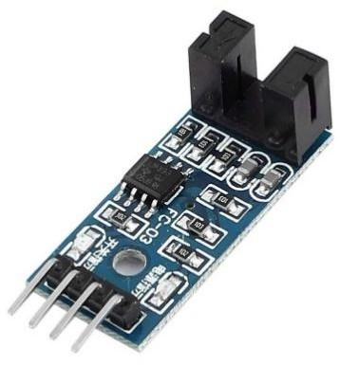
The LM393 RPM measurement sensor is a simple and inexpensive way to measure the rotational speed of a motor or other rotating device. The LM393 RPM measurement sensor works on the principle of optical coupling. The sensor consists of an infrared LED and a phototransistor, which are mounted on a small PCB. When the LED turned on, it emits a beam of infrared light. If the beam interrupted by the rotating shaft, the phototransistor will detect the interruption and generate an electrical pulse. The number of pulses per second is proportional to the rotational speed of the shaft. The LM393 RPM measurement sensor can be used with a microcontroller to measure the rotational speed of a motor or other rotating device. The microcontroller can count the number of pulses per second and then convert the count to RPM The LM393 RPM measurement sensor can operate on a voltage range of 3.3V to 5V. The input voltage is applied to the VCC pin of the sensor. The sensor will output a TTL signal on the DO pin, which is active low. The output signal will be high when the sensor is not detecting any pulses, and it will be low when the sensor is detecting pulses.
Advantages:
    - Simple and inexpensive solution for RPM measurement.
    - Provides high accuracy in clean environments.
    - TTL-compatible digital output makes it easy to interface with microcontrollers.
    - Works well at high speeds due to sharp pulse generation.
Disadvantages:
    - Sensitive to dust, dirt, and oil, which may block the optical path.
    - Requires precise alignment of the sensor and rotating shaft.
    - Limited working distance between encoder disk and sensor.
- By Using Halls Effect Sensor Module (3144):
Hall Effect Sensor Module 3144 is a small, inexpensive sensor that can use to detect the presence of a magnetic field. It has two outputs: a digital output that turns on or off when a magnet is near, and an analog output that measures the strength of the magnetic field. The sensitivity of the Magnetic Hall Module can adjust by using the potentiometer. The potentiometer is a variable resistor that can use to increase or decrease the amount of current flowing through the Hall sensor. This, in turn, affects the amount of Hall voltage produced. A thin piece of semiconductor material (Hall Element) with current flowing through it. When subjected to a magnetic field, it produces a voltage perpendicular to both the current and the magnetic field. A permanent magnet or an electromagnet placed in close proximity to the Hall element. The voltage generated by the Hall element is usually very small. An amplifier or comparator is used to amplify and process the signal. Working Steps: The sensor is placed in the vicinity of the rotating part of the motor (e.g., a gear with a magnet attached). As the motor rotates, the magnetic field interacts with the Hall element in the sensor (Hall Effect). Voltage Generation: The Hall element generates a voltage (Hall voltage) proportional to the strength of the magnetic field. Amplification/Processing: The generated voltage is then amplified or processed by the built-in electronics in the sensor. The sensor produces a digital or analog output signal that corresponds to the RPM of the motor. Attach the Hall Effect Sensor 3144E in a position where it can detect the rotating part of the motor. Attach a magnet to the rotating part of the motor. As the motor rotates, the magnetic field changes, causing the Hall Effect Sensor to generate a voltage. Connect the output of the sensor to a microcontroller or RPM measuring device. The microcontroller can then process the signal and calculate the RPM based on the frequency of the Hall sensor output.
Advantages:
  - Robust and reliable in harsh environments (dusty, oily, or dirty).
  - Can detect speed even at low RPM where optical sensors may fail.
  - Easy to mount just attach a small magnet to the rotating part.
  - Sensitivity can be adjusted with an onboard potentiometer.
  - Longer sensing distance compared to optical encoders.
Disadvantages:
    - Slightly less accurate than optical encoders in precision applications.
    - Requires a magnet to be mounted on the shaft, adding mechanical work.
    - Output depends on magnet strength and sensor placement (alignment critical).
    - At very high speeds, missed pulses can occur if the sensor/magnet is not well aligned.

- Microcontroller Module (STM32):
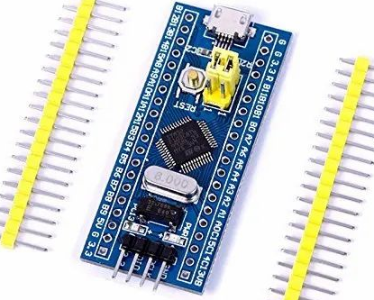
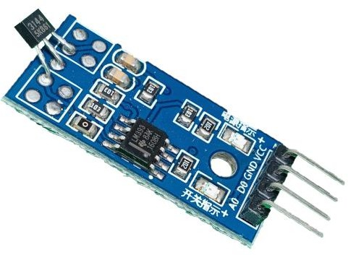
The STM32 is a family of 32-bit microcontrollers developed by STMicroelectronics, based on the ARM Cortex-M architecture. It is widely used in embedded systems due to its high performance, low power consumption, and extensive peripheral support. STM32 microcontrollers provide a wide range of features such as multiple timers, ADCs, DACs, PWM channels, communication interfaces (UART, SPI, I²C, CAN, USB, Ethernet), and real-time clock modules, making them highly versatile for control and automation applications. In motor control systems, STM32 plays a vital role by generating precise PWM signals, executing real-time control algorithms such as PID, and interfacing with speed/position sensors. Compared to simpler controllers like Arduino, STM32 offers faster processing, higher resolution ADCs, and advanced debugging capabilities, which result in more accurate and efficient control. Due to its scalability and cost-effectiveness, STM32 is a preferred choice in industrial automation, robotics, and power electronics projects.
Advantages:
- Based on ARM Cortex-M cores, STM32 provides fast processing speeds and supports real-time
applications like motor speed control.
- It includes built-in ADCs, DACs, PWM channels, timers, and multiple communication interfaces, reducing the need for external components.
- Designed for energy-efficient operation, making it suitable for battery-powered and industrial applications.
Disadvantages:
  - Programming and configuration can be challenging for beginners compared to simpler boards like Arduino.
  - Requires use of professional IDEs (Keil, STM32CubeIDE) and understanding of hardware abstraction layers, which increases learning curve.
  - Certain STM32 variants are more expensive and sometimes harder to source than entry-level microcontrollers.

List of Tasks needed to be completed to fulfill the Problem Statement requirements
- Research and Initial Planning:

This stage involves conducting background research on DC motor speed control and three-phase AC to DC conversion. The system requirements will be defined, and the overall project design will be outlined to ensure a clear roadmap for implementation.
- Components Selection:

In this step, the necessary hardware components such as rectifiers, converters, sensors, and microcontrollers will be selected along with software tools like MATLAB, Multisim, and Arduino IDE. Compatibility and availability will also be ensured.
- Design and Simulation of Power Conversion:

The rectifier and converter circuits will be designed and simulated using software tools. This step will validate the feasibility and efficiency of the power conversion process before proceeding to hardware implementation.
- Development and Testing of the Speed Control System:

Control strategies such as Pulse Width Modulation (PWM) and Proportional-Integral-Derivative (PID) control will be designed and tested through simulations. This ensures the motor speed can be adjusted and maintained under varying load conditions.
- Microcontroller Programming:

The Arduino microcontroller will be programmed to integrate the sensors, execute control algorithms, and manage the overall system operation. Testing of the code will be performed to ensure functionality.
- Building, Integration, and System Testing:

All components, including hardware and software, will be assembled into a working prototype. The integrated system will then be tested under different conditions to check performance, stability, and reliability.
- Report Writing:

A detailed report will be prepared covering the design, methodology, simulations, results, and conclusions of the project. Proper documentation will ensure clarity and traceability of the work completed.
- Final Testing and Submission:

The project will conclude with final testing to validate performance. The results will be compiled, and the complete project (prototype, report, and presentation) will be submitted for evaluation.
Resource Identification
Human Resource Skill Gap
S.No. | Name | Roll No. | Section | Skill
1 | Muhammad Taha* | EE-23319 | D | Circuit simulation (Multisim, MATLAB), Arduino programming, soldering, report writing & documentation.
2 | Ali Nasir | EE-23328 | D | Hardware assembly, soldering, troubleshooting, sensor integration, testing.

Hardware Resource Identification
S. No. | Hardware Component/Equipment Name | Where/How to acquire
1 | Vero board | Co-operative Market
2 | Screw connectors (2pin/3pin) | Co-operative Market
3 | Diodes (3A) | Co-operative Market
4 | Resistors (1% tolerance) | Co-operative Market
5 | Load resistance (8.2ohm,10W) | Co-operative Market
6 | Inductor (6.8mH) | Co-operative Market
7 | Pin male headers | Co-operative Market
8 | Transformer (220v to12-12v, 1A) | Co-operative Market
9 | Thyrioster (BT151,C106) | Co-operative Market
10 | Arm controller (STM 32F401) | Co-operative Market
11 | ST-LINK V₂ (STM 32F401) | Co-operative Market
12 | Capacitor (330µF,1000µF,470µF) | Co-operative Market
13 | Mosfet Module | Co-operative Market

Software Resource Identification
S. No. | Software Name | Where/How to acquire
1 | Multisim | From NI (National Instruments)
2 | Arduino IDE | From Arduino official website
3 | MATLAB | From University (Campus License / Student Access)

Project Objectives
- Design and Simulation of Power Conversion System:
To design and simulate an efficient three-phase AC to DC conversion system using rectifier and converter circuits in Multisim and MATLAB, ensuring accurate voltage regulation suitable for DC motor speed control applications.
- Development of Intelligent Speed Control Mechanism:
To implement and test advanced control strategies such as PWM and PID control on a microcontroller (Arduino/STM32), enabling precise adjustment and stable regulation of motor speed under varying load conditions.
- Prototype Integration and Validation:
To integrate hardware and software components, including sensors, rectifier, controller, and motor—into a fully functional prototype, followed by rigorous testing to validate performance, efficiency, and reliability.
- Documentation and Knowledge Contribution:
To compile a comprehensive project report and presentation that highlights the design methodology, experimental results, and potential industrial applications, ensuring the project contributes to future academic and professional reference.
Project Deliverables
- Prototype Speed Control System:
A working model demonstrating the control of DC motor speed using a three-phase AC input. It includes all integrated hardware components and is tested for both reliability and performance.
- Simulation Model:
A validated simulation developed using software tools (e.g., Multisim, MATLAB/Simulink) to analyze motor behavior and evaluate different control strategies.
- Integration Report:
A comprehensive report outlining the integration of various system components, including the DC motor, three-phase AC supply, control circuitry, and sensors, with detailed results and analysis.
- Final Presentation:
A professional presentation summarizing the project objectives, design approach, outcomes, and applications for evaluation.
Resource Allocation and Time Scheduling
Human Resource Allocation
Task / Objective | Muhammad Taha* | Ali Nasir
Research & Initial Planning | (Lead research, simulation approach) | (Support)
Components Selection | (Identify simulation requirements, controller) | (Select hardware components, sensors)
Design & Simulate Power Conversion | (Multisim, MATLAB simulations) | –
Develop & Test Speed Control System | (PWM & PID in Arduino) | (Hardware testing, soldering)
Microcontroller Programming | (Arduino coding, debugging) | –
Build, Integrate & Test System | (System coordination, documentation) | (Hardware assembly, soldering, troubleshooting)
Report Writing | (Lead documentation, analysis) | –
Final Testing & Submission | (Validation, presentation prep) | (Testing support, validation)
Research & Initial Planning | (Lead research, simulation approach) | (Support)
Components Selection | (Identify simulation requirements, controller) | (Select hardware components, sensors)
Design & Simulate Power Conversion | (Multisim, MATLAB simulations) | –
Develop & Test Speed Control System | (PWM & PID in Arduino) | (Hardware testing, soldering)

Hardware/Software Resource Allocation
Task / Objective | Hardware Resources | Software Resources
Research & Initial Planning | – | Online resources, MATLAB (literature & design review)
Components Selection | DC motor, sensors, rectifier, converter | –
Design & Simulate Power Conversion | – | Multisim, MATLAB/
Develop & Test Speed Control System | Arduino board, motor driver | MATLAB, Arduino IDE
Microcontroller Programming | STM32 / equivalent | Arduino IDE
Build, Integrate & Test System | DC motor, power supply, sensors, rectifier, converter, soldering tools | Multisim (reference), Arduino IDE
Report Writing | – | MS Word
Final Testing & Submission | Complete hardware prototype | –

Time Scheduling
S. No. | Task | Timeline | Hardware Resources | Software Resources
1 | Research & Initial Planning | September (Week 1-2) | – | Online resources, MATLAB
2 | Components Selection | September (Week 3) | DC motor, sensors, rectifier, converter | –
3 | Design & Simulate Power Conversion | October (Week 2-3) | – | Multisim, MATLAB
4 | Develop & Test Speed Control System | October (Week 4-5) | Arduino board, motor driver | MATLAB, Arduino IDE
5 | Microcontroller Programming | October (Week 5) | Arduino Uno / equivalent | Arduino IDE
6 | Build, Integrate & Test System | November (Week 1-2) | DC motor, power supply, sensors, rectifier, converter, soldering tools | Multisim (reference), Arduino IDE
7  8 | Report  Submission | November(Week 3-4)  November (Week 4) | –  Printed copy | MS Word  –
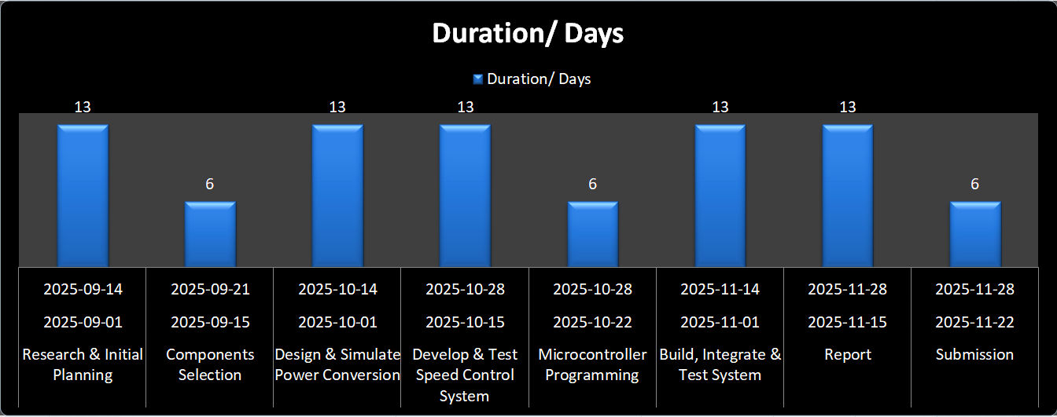

Budgeting and Bill Of Materials (BOM)
Estimated BOM
S.No. | Equipment/Component Name | Estimated Cost (PKR) | Reference of Cost Estimate
1 | Vero board | 100 | Co-operative Market
2 | Screw connectors (2pin/3pin) | 15, 20 | Co-operative Market
3 | Diodes (3A) | 5 | Co-operative Market
4 | Resistors (1% tolerance) | 2 | Co-operative Market
5 | Load resistance (8.2ohm,10W) | 25 | Co-operative Market
6 | Inductor (6.8mH) | 15 | Co-operative Market
7 | Pin male headers | 15 | Co-operative Market
8 | Transformer (220v to12-12v, 1A) | 280 | Co-operative Market
9 | Thyrioster (BT151,C106) | 30 | Co-operative Market
10 | Arm controller (STM 32F401) | 800-900 | Co-operative Market
11 | ST-LINK V₂ (STM 32F401) | 800-900 | Co-operative Market
12 | Capacitor (330µF,1000µF,470µF) | 12,20,15 | Co-operative Market
13 | Mosfet Module | 1350 (1 pieces) | Co-operative Market
 | Total Cost: | 5130

Budget Funding
Each member will contribute an equal share of the total budget required.
Risk Assessment
Risk Assessment
The main risks included possible hardware failures such as the Microcontroller or DC motor not working properly. Poor soldering in some parts of the circuit caused loose connections, which weakened the circuit performance. Software errors in MATLAB slowed progress and sometimes made the systemact in a wrong way. Errors or mistakes in the code took extra time to find and fix. Sometimes changes or updates in the software caused new problems that needed to be checked and corrected before moving further which caused delays.
References
[1] N. Mohan, T. M. Undeland, and W. P. Robbins, Power Electronics: Converters, Applications, and Design. Hoboken, NJ, USA: John Wiley & Sons, 2003.
[2] M. H. Rashid, Power Electronics: Circuits, Devices, and Applications, 4th ed. Upper Saddle River, NJ, USA: Pearson, 2013.
[3] “Speed Control of DC Motors,” University of Diyala, [Online]. Available: https://engineering.uodiyala.edu.iq/uploads/depts/power/teacher%20lectures/Speed+Control+of+DC+motors.pdf.
[4] “Speed Control of DC Motor – Methods and Applications,” Electrical4U, 2023. [Online]. Available: https://www.electrical4u.com/speed-control-of-dc-motor/.
[5] “Lecture Notes on Power Electronics,” University of Misan, [Online]. Available: https://www.uomus.edu.iq/img/lectures21/MUCLecture_2025_2546476.pdf.
[6] “Three Phase Rectification,” Electronics Tutorials, [Online]. Available: https://www.electronics-tutorials.ws/power/three-phase-rectification.html.
[7] “Speed and Direction Control of DC Motor,” International Journal of Recent Technology and Engineering, Paper Publications, 2025. [Online]. Available: https://www.paperpublications.org/upload/book/Speed%20and%20Direction%20Control%20of%20DC%20Motor-25072025-1.pdf.
[8] “Arduino IDE,” Arduino. [Online]. Available: https://arduino.cc/en/software.
[9] “NI Multisim — Downloads & Support,” National Instruments. [Online]. Available: https://www.ni.com/en/support/downloads/software-products/download.multisim.html?srsltid=AfmBOoodHZdk6nLeHwjN3gyNDQGHIXJGc11CgTI-1_PKXx6CNDHXnjDQ#452133.
[10] “MATLAB — Search Results,” Google. [Online]. Available: https://www.google.com/search?q=matlab+download&oq=matlab&gs_lcrp=EgZjaHJvbWUqEwgDEAAYgwEYkQIYsQMYgAQYigUyBggAEEUYPDIOCAEQRRgnGDsYgAQYigUyDAgCECMYJxiABBiKBTITCAMQABiDARiRAhixAxiABBiKBTINCAQQABiDARixAxiABDIGCAUQRRg8MgYIBhBFGDwyBggHEEUYPNIBCDYxNjhqMGo0qAIAsAIA&sourceid=chrome&ie=UTF-8.
Submission at the time of Evaluation
- Original source file for Gantt Chart
- Proof of survey of market/online-vendors for BOM
- Partial/complete set of equipment bought for the project

Skill(s) to be assessed | Extent of Achievement
Skill(s) to be assessed | <50% | 50%-65% | 65%-80% | 80%-100%
Resource identification and allocation | Unable to identify and allocate | Partial identification and allocation | Partial identification or Partial allocation | Complete identification and allocation
Task identification and scheduling | Unable to identify and schedule | Partial identification and poor scheduling | Partial identification or Poor scheduling | Complete identification and proper scheduling
Bill of Materials (BOM) and budgeting | No BOM and budgeting | Incomplete BOM and budgeting | Complete BOM and budgeting with errors | Complete BOM and budgeting with no errors
Risk assessment and management | Unable to identify risks and unable to propose mitigation plan | Identifies risks correctly but unable to propose mitigation plan | Partial risk identification and partial mitigation plan proposed | Comprehensive risk assessment and mitigation plan presented

